**USER GUIDE**

**DRTST**

**DISASTER RESPONSE TRADE STUDY TOOL**

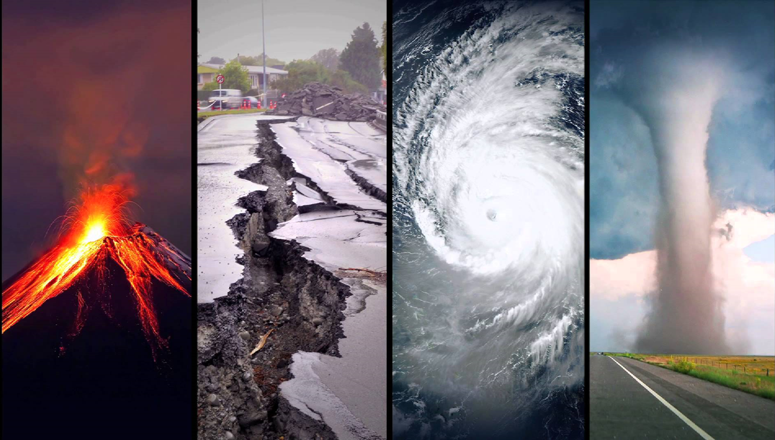

Table of Contents

1 General Information 1

1.1 Purpose 1

1.2 System Configuration 1

1.2.1 Configuration Requirements 1

1.3 User Assumptions and Access Levels 1

1.3.1 DRTST program 1

1.3.2 DRTST Technology Options Databases 1

1.4 Problem Reporting 2

2 Getting Started 2

2.1 Installation 2

2.2 Exit DRTST 2

3 Using DRTST 3

3.1 Dashboard 3

3.2 Disaster Effects Tab 3

3.3 Environment Definition Tab 6

3.4 Define Weighting Criteria 14

3.5 Calculating the Results 18

4 DRTST Technology Databases 21

4.1 Platform Database 22

4.2 Communications Technology Database 23

4.3 Sensor Technology Database 24

4.4 Terrain Effect Codes 26

4.5 Disaster Effect Codes 27

# General Information

## Purpose

The Disaster Response Trade Study Tool (DRTST) is designed for use at a state/regional/federal level in order to make long term funding and acquisition decisions on the types of technology solutions to better prepare for disaster response. The use of the tool could be at a local level but will most likely be at the state or federal level, or its equivalents in foreign nations. The user inputs the types of disasters that concern them as well as information about the environment such as the population density, terrain, and transportation infrastructure. The tool will output a list of technology descriptions that best meet the user’s chosen inputs.

## System Configuration

Prior to beginning installation procedures for DRTST, check the system configuration requirements below. If your system does not meet these requirements, DRTST will not run correctly. Update your system to align with the requirements below before proceeding.

### Configuration Requirements

* Windows 7 OS or greater
* Microsoft Office 2007 or later
* Java Runtime Environment (JRE) version 8 or later
  + See <http://www.oracle.com/technetwork/java/javase/certconfig-2095354.html> for reference

DRTST uses Java as its primary interface. The databases containing the technology set options are maintained in Microsoft Excel. Note: The trade study relies on the databases to make proper decisions on recommended technology sets. Any edits to these databases should be made by personnel who understand the capabilities of the various technologies being edited.

## User Assumptions and Access Levels

### DRTST program

Anyone can use the DRTST program. There are no administrative controls for the tool. The user should possess a well-rounded understanding of disaster response operations, knowledge of the required information needs of the organization, and geographical information related to both potential disaster locations and their effects (e.g. smoke, ash, etc.). In addition, the user should possess an understanding of how key performance parameters of technology systems impact the data’s usefulness to the disaster response operation.

### DRTST Technology Options Databases

As stated above, the technology options databases are the key source of information for the trade study tool. Only personnel who are domain experts in the technology options and who understand the software and the specific data requirements of the trade study tool should modify these databases. There are currently no administrative controls on the database files that are used to conduct the trade study analysis.

## Problem Reporting

Since the DRTST development team will be dissolved after the initial release, refer questions and problem reporting to the Georgia Institute of Technology Professional Master’s Degree in Applied Systems Engineering Program. Contact information is below.

[andy.register@gtri.gatech.edu](mailto:andy.register@gtri.gatech.edu), 404-407-7916

# Getting Started

## Installation

Extract the DRTST zip file and save the contents to the appropriate directory for your organization. The unzipped folder will contain contents as shown in Figure 1. Once the file has been saved to the desired location, double click on the Disaster Response Trade Study Tool application file to start the DRTST program.

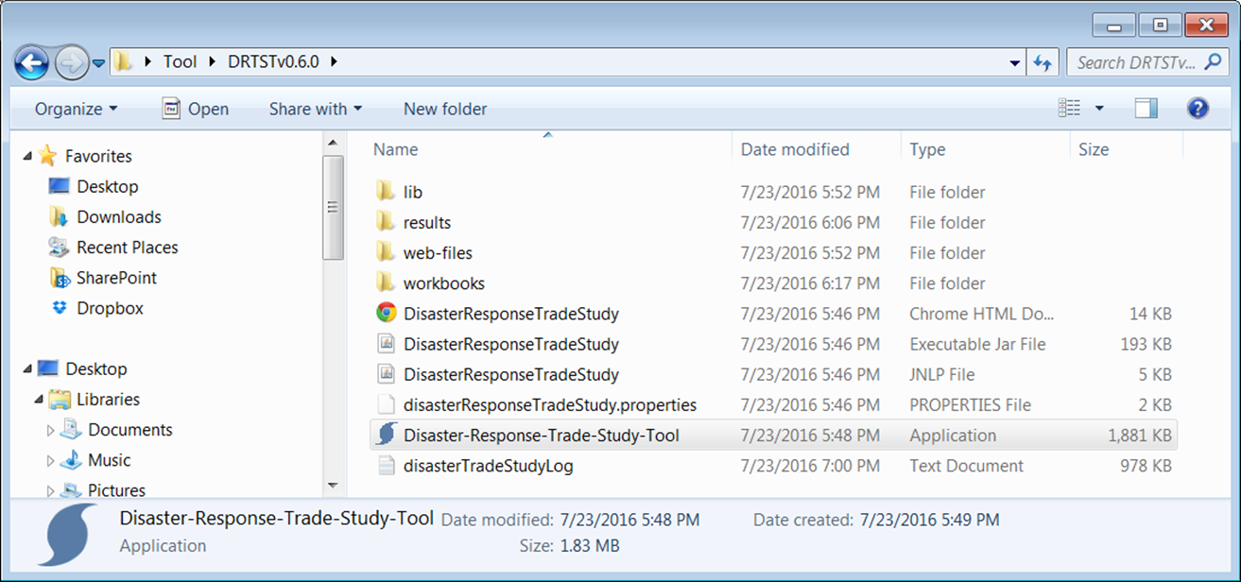

Figure 1: DTRTS Folder Contents

## Exit DRTST

To exit the DRTST program, simply select the ‘X’ in the upper right corner of the Dashboard. The DRTST does not save any inputted user data. When closing the program all user inputs will be lost. However, the DRTST results are presented in a Microsoft Word document and can be saved for future reference or printing.

# Using DRTST

## Dashboard

The first menu to appear after opening the DRTST program is the dashboard (Figure 2). This screen will allow the user to navigate to all of the required menus to set up the trade study analysis.

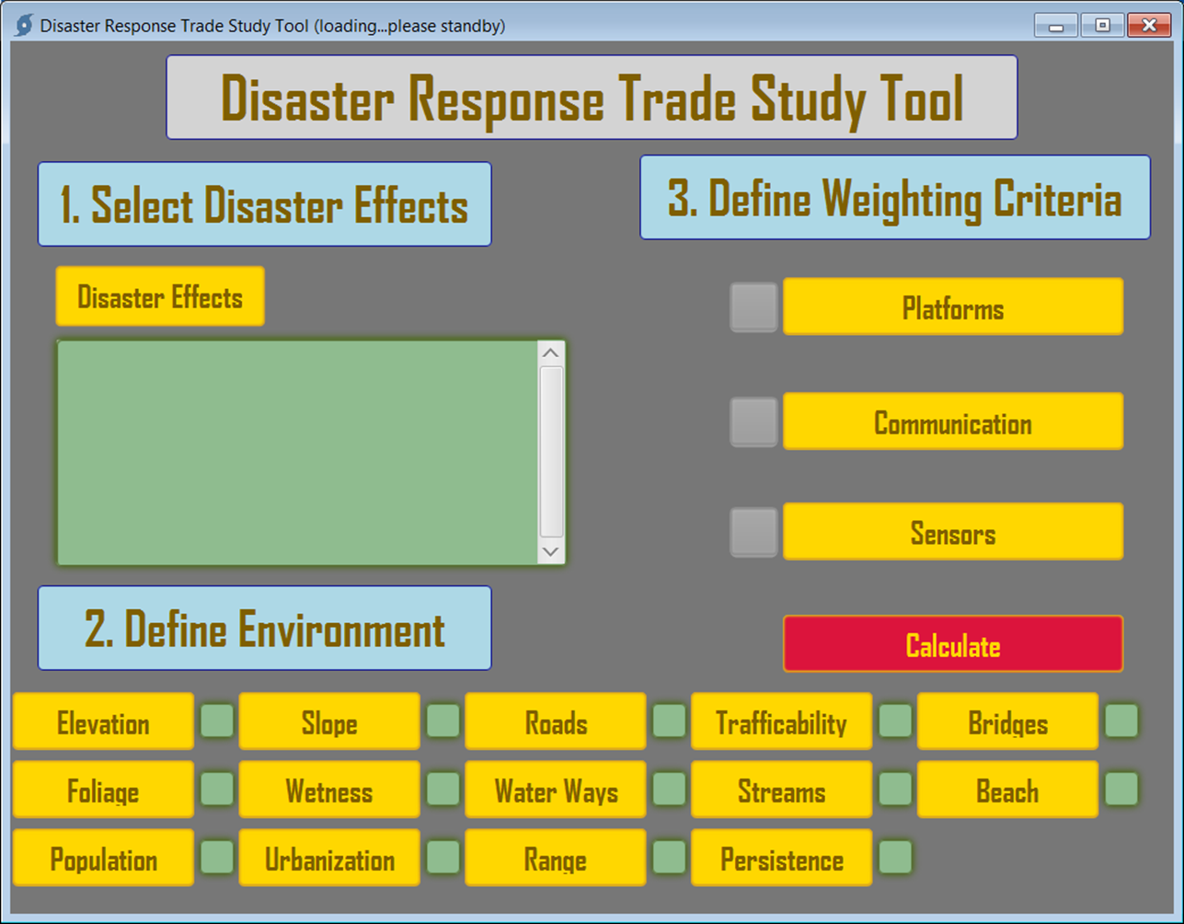

Figure 2: DRTST Dashboard

As the user inputs parameters into the various modules of the DRTST the dashboard will reflect the updates and the user will then run the final calculation command from this page.

## Disaster Effects Tab

The first step in the trade study process is to select the disaster effects that are of concern to the user. These effects could be focused around a single disaster or could be a complete list of all effects from a variety of disasters that the using organization must face. Use caution when selecting effects as any omissions will not factor into the trade study analysis and therefore might not produce the recommended solutions that would actually be needed. Conversely, selecting every available effect may also provide unrealistic solution sets (or no solution at all) as it is unlikely every effect would be a potential concern to a given area. To select the disaster effects for the tool to consider, click on the “Disaster Effects” button on the dashboard as shown in Figure 3.

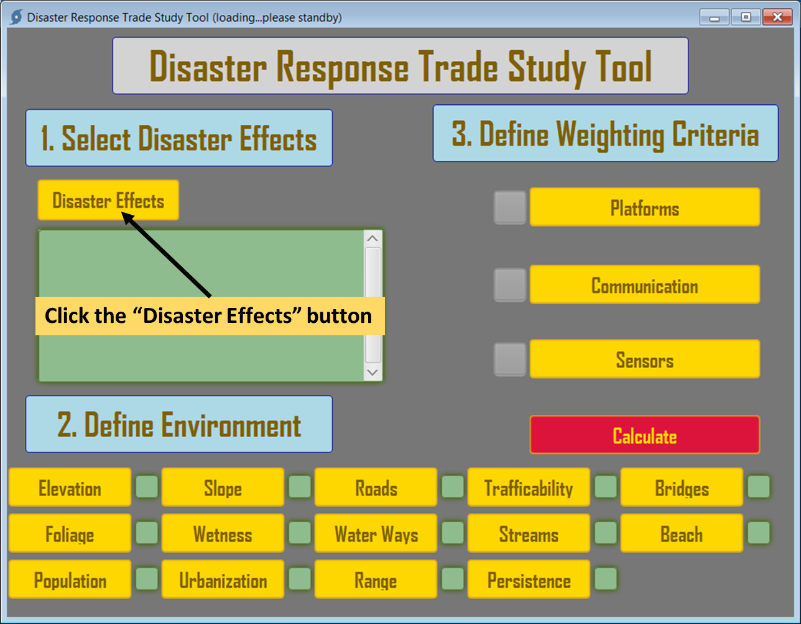

Figure 3: Step 1 - Selecting the Disaster Effects

This will open an effects selection menu as shown in Figure 4. The user then selects all the effects that will be used in this session for consideration, after which they select “Done” to return to the dashboard.

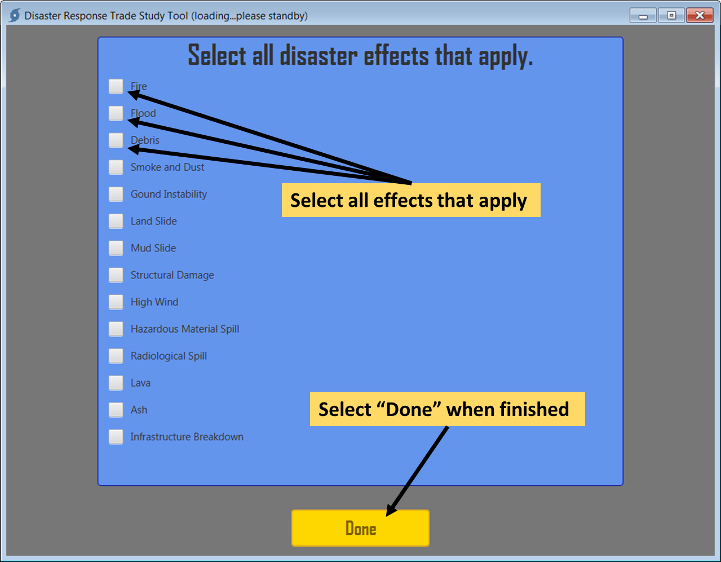

Figure 4: Effects Selection Menu

After making disaster effects selections and hitting “Done” the program will return to the dashboard where all of the indicated effects chosen will be displayed as shown in Figure 5.

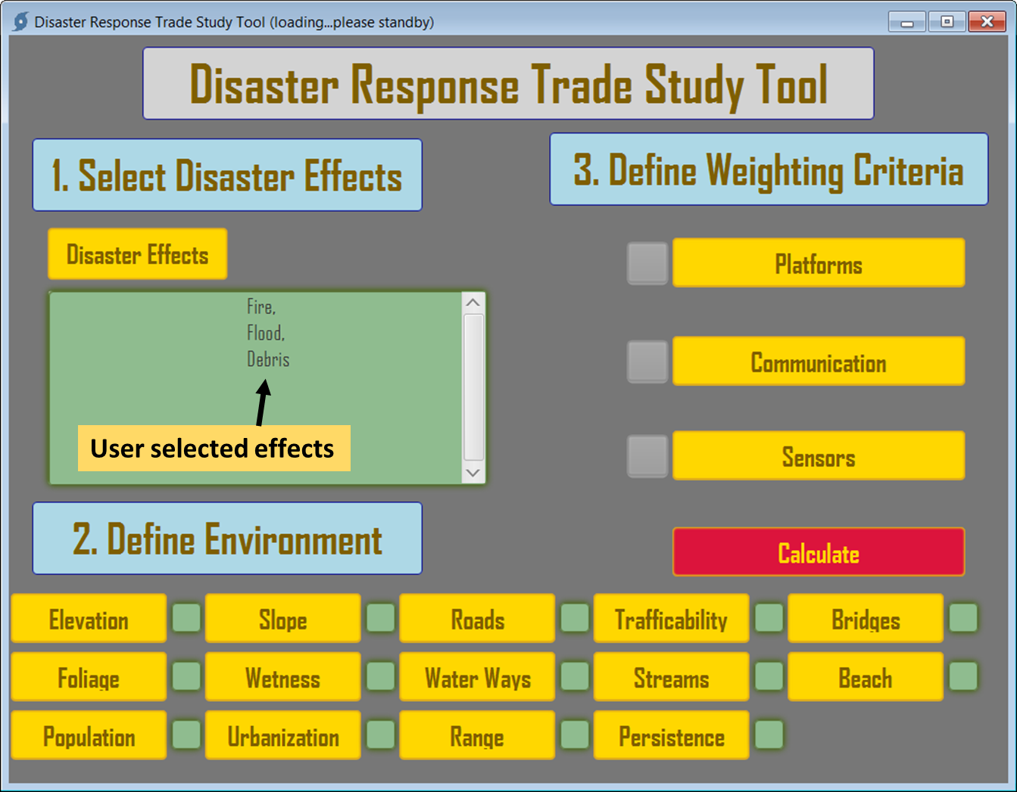

Figure 5: DRTST Dashboard with User-selected Effects Displayed

## Environment Definition Tab

Next the user will define the environment that is the focus of the disaster planning effort. At the bottom of the dashboard, there are numerous buttons that will take the user to menus that help describe the environmental factors that will be key in formulating technology solutions during the trade study analysis. Next to each environment definition button is a window which will show the selected level of each factor which ranges from 0 – 4. As an example; when the user selects elevation by clicking on the “Elevation” button on the dashboard, a window is displayed that describes the selection criteria as in Figure 6.

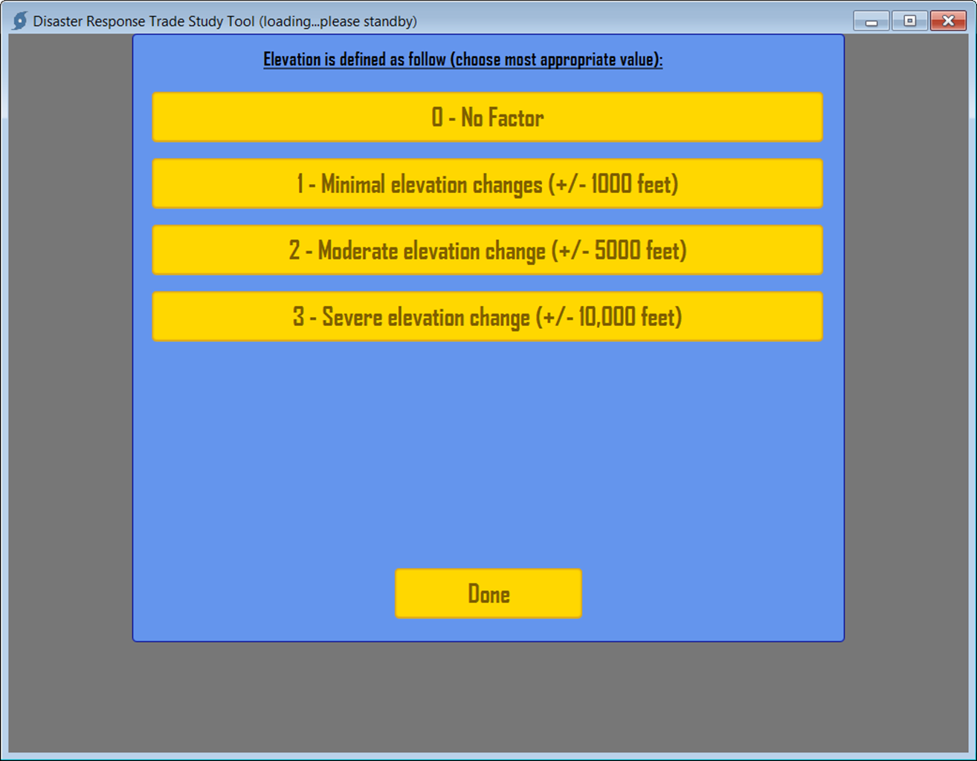

Figure 6: Elevation Environmental Factors Menu

In this case, the user is being asked to describe the terrain in the area for which disaster planning is being conducted in very basic terms. If the terrain was moderately mountainous with elevation changes (+/- 5,000 feet), button 2 would be selected in this menu (Figure 7).

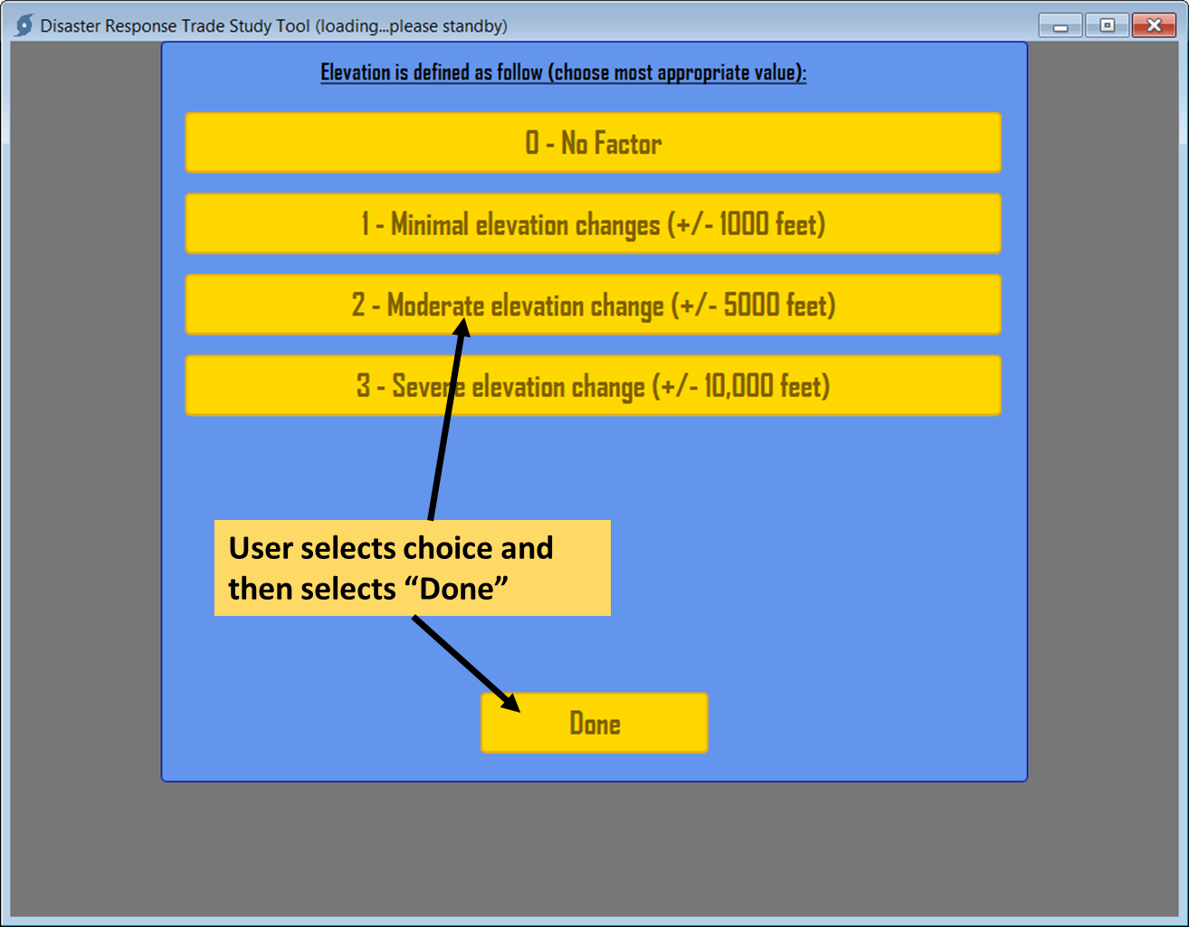

Figure 7: Selection of Elevation Factor (clicking on button #1)

After selecting the desired factor button, the user selects “Done” and program will go back to the dashboard and the small status box next to the environmental factor will be updated with the selected number as shown in Figure 8.

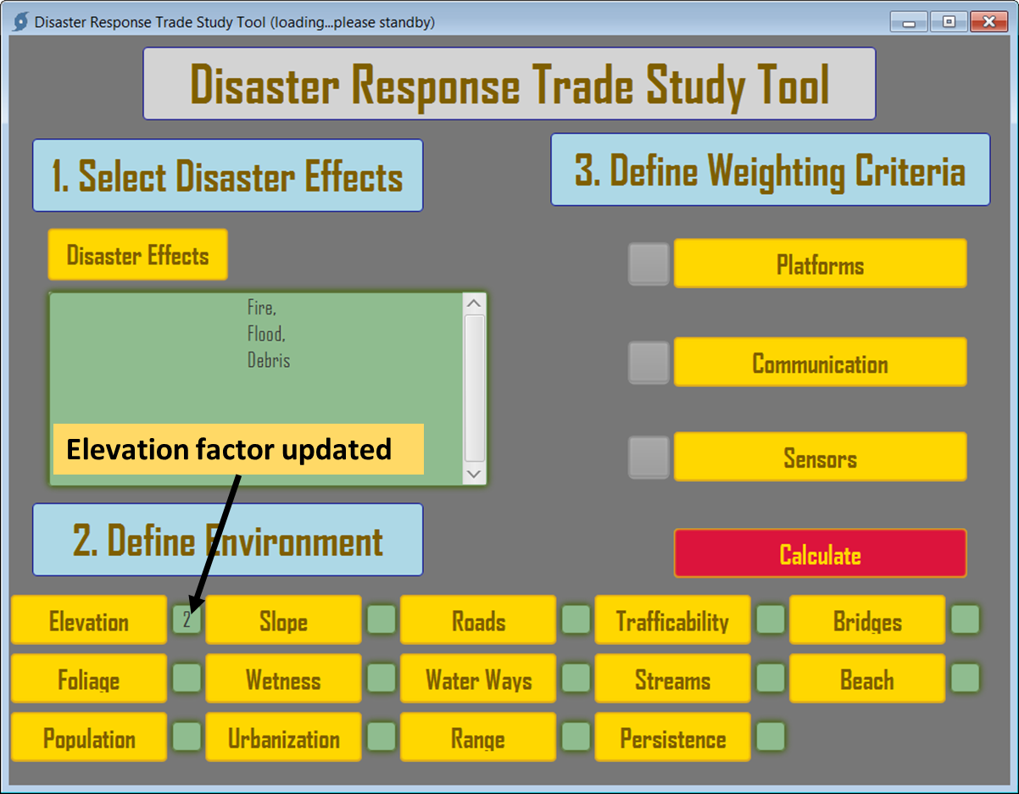

Figure 8: Dashboard with "Elevation" Factor Populated

The dashboard has an added feature pertaining to the environment factors that allows the user to hover the mouse pointer over the factor number to display the criteria that made up the selection as shown in Figure 9.

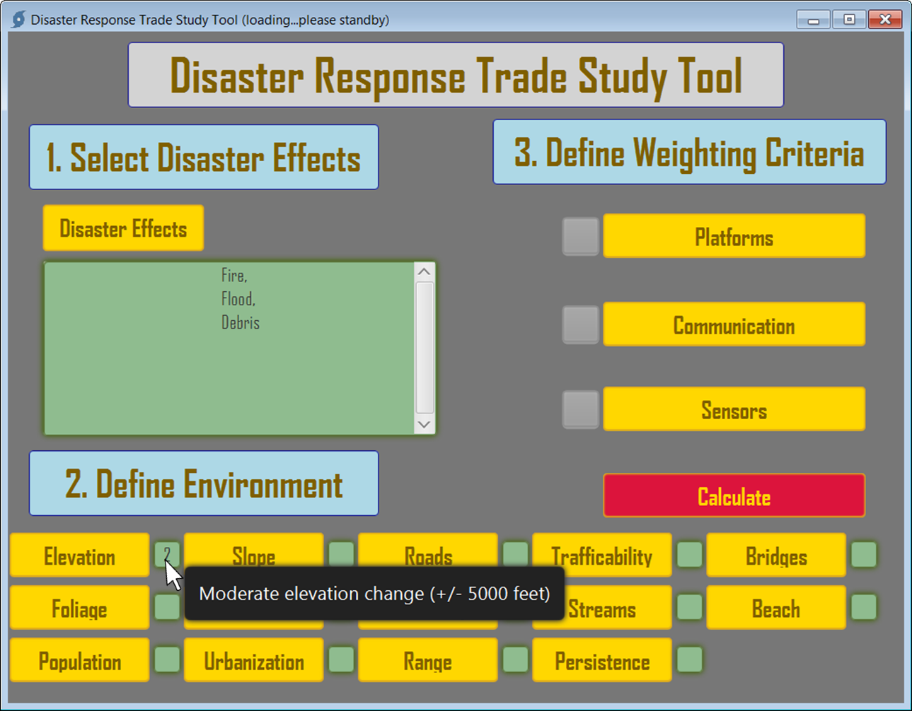

Figure 9: Expanded information via Mouse Hover Option

The user continues to select each environment factor in the same manner as above. There is no specific order that is required for the environment factor selection. The tool initializes without any settings in the environment factors. Each must have an established factor in order for the tool to render a calculation. Zero (0) factor is used for any of the definitions the user does not want the trade study algorithm to consider in its calculations.

The remaining menus are shown in Figure 10 through Figure 22.

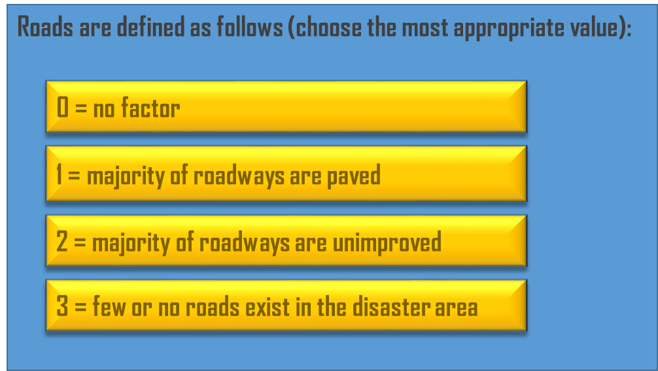

Figure 10: Defining Road Network

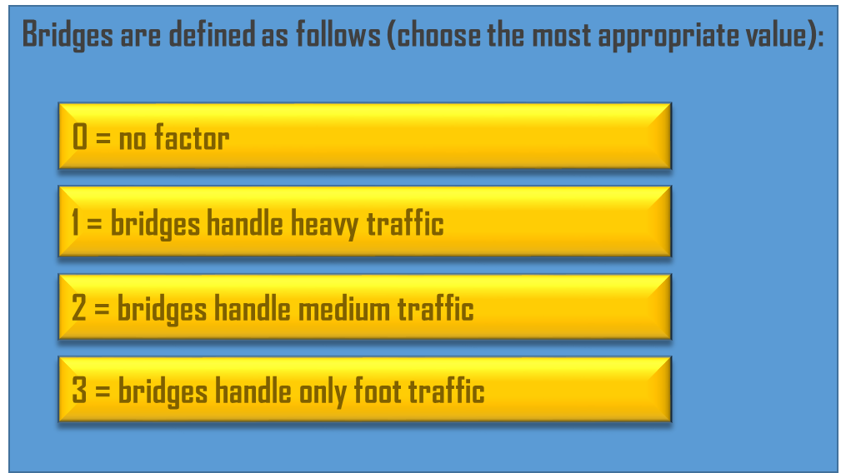

Figure 11: Defining Bridge Infrastructure

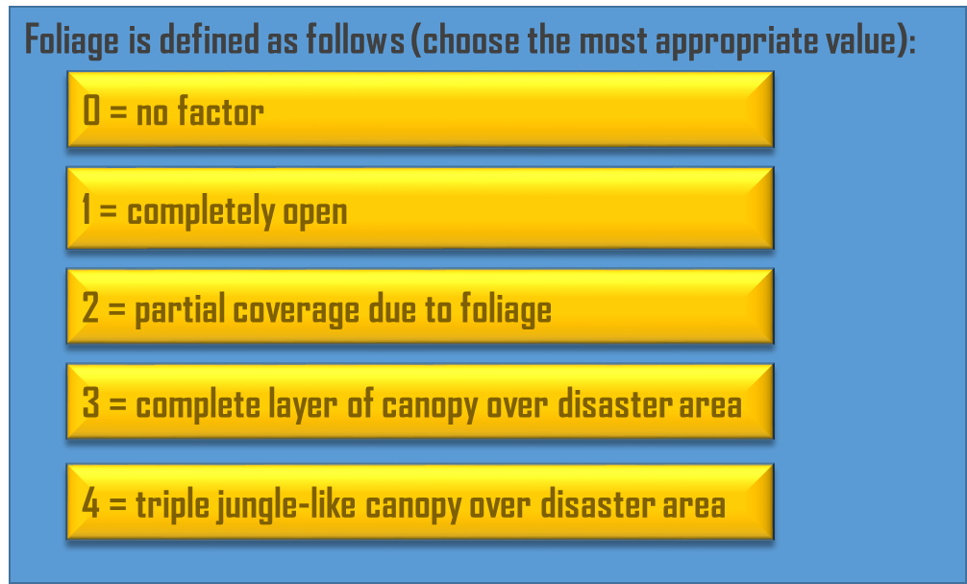

Figure 12: Defining Foliage Density

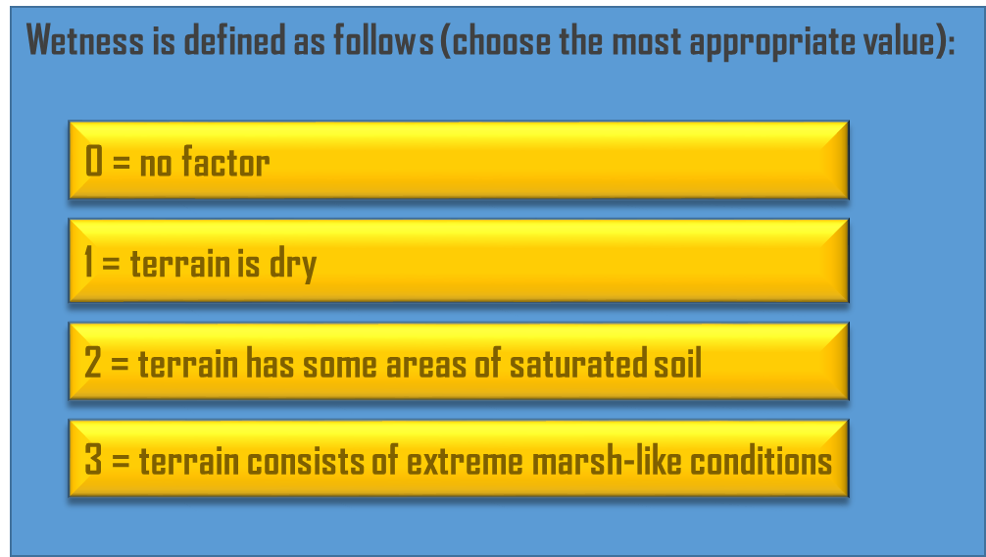

Figure 13: Defining Level of Moisture

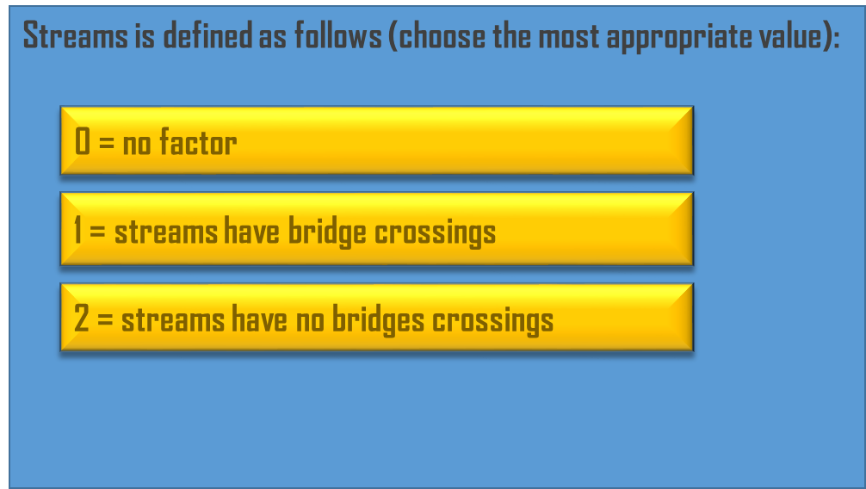

Figure 14: Define Stream Crossing Capability

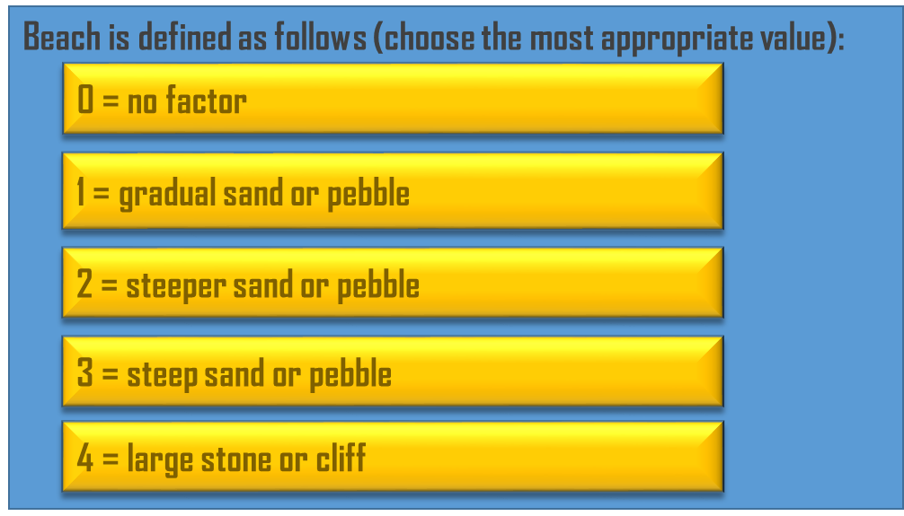

Figure 15: Define Coastal Makeup

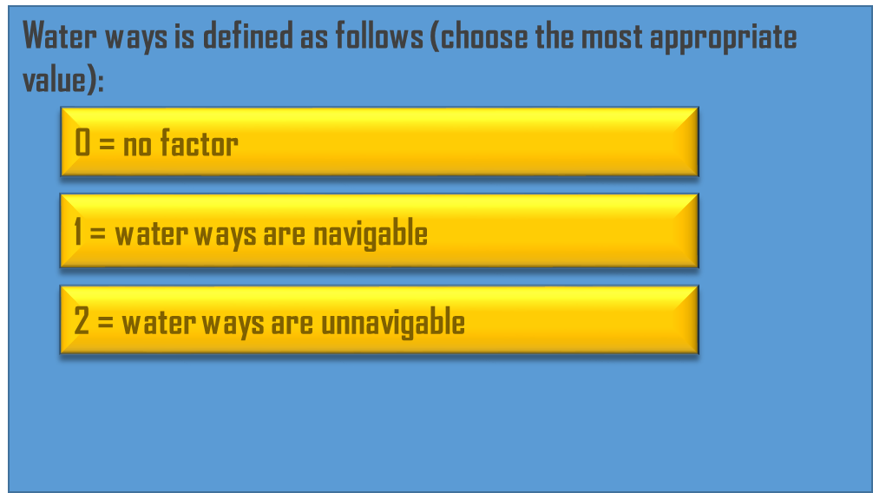

Figure 16: Define Waterway Access

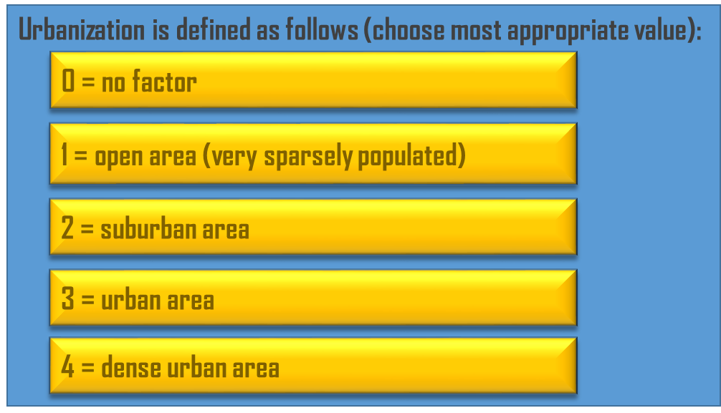

Figure 17: Define Level of Urbanization

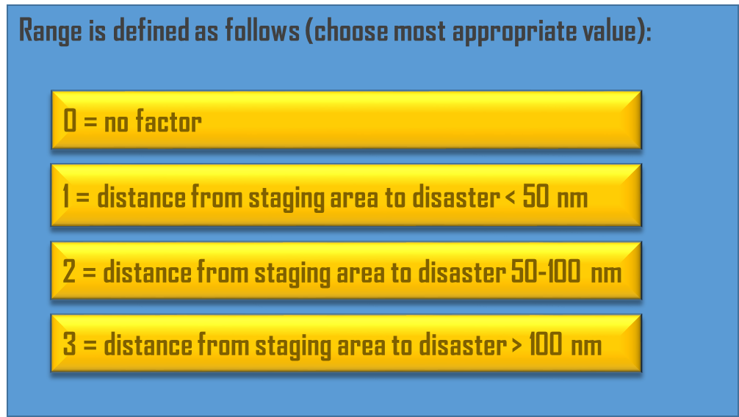

Figure 18: Define Distance Between Staging Area and Disaster Site

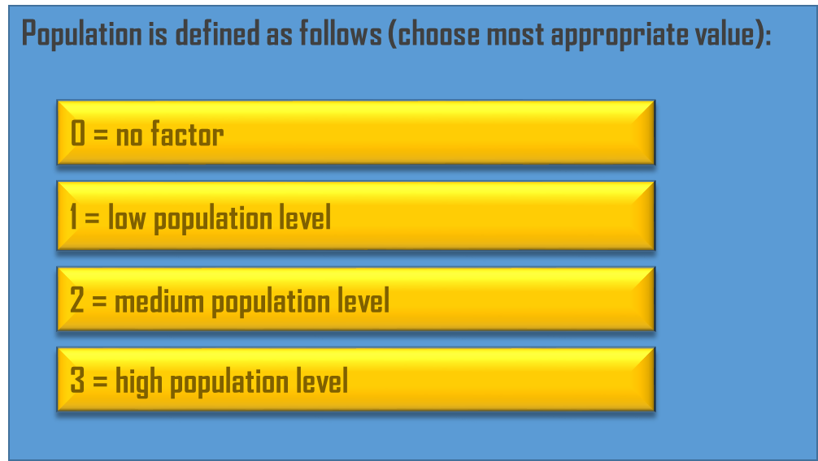

Figure 19: Define Population Levels

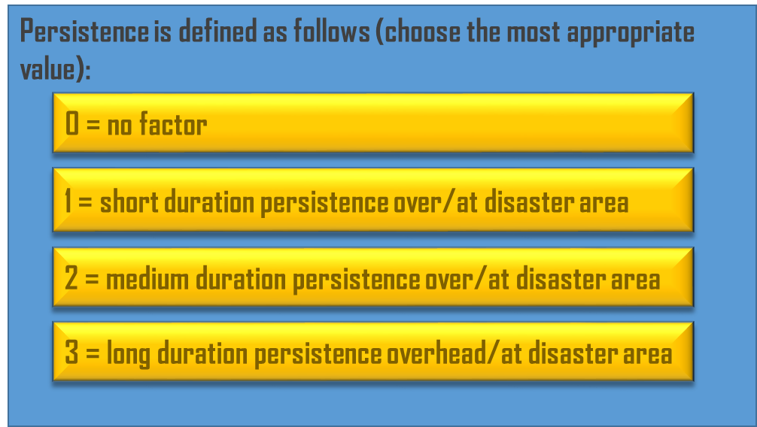

Figure 20: Define Necessary Persistence

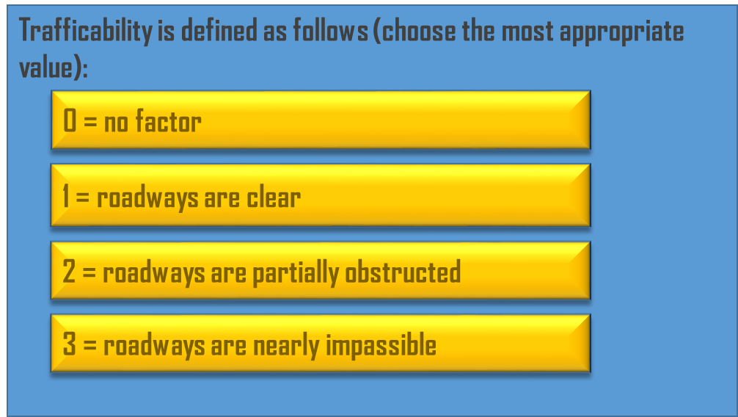

Figure 21: Define Trafficability of Roadways

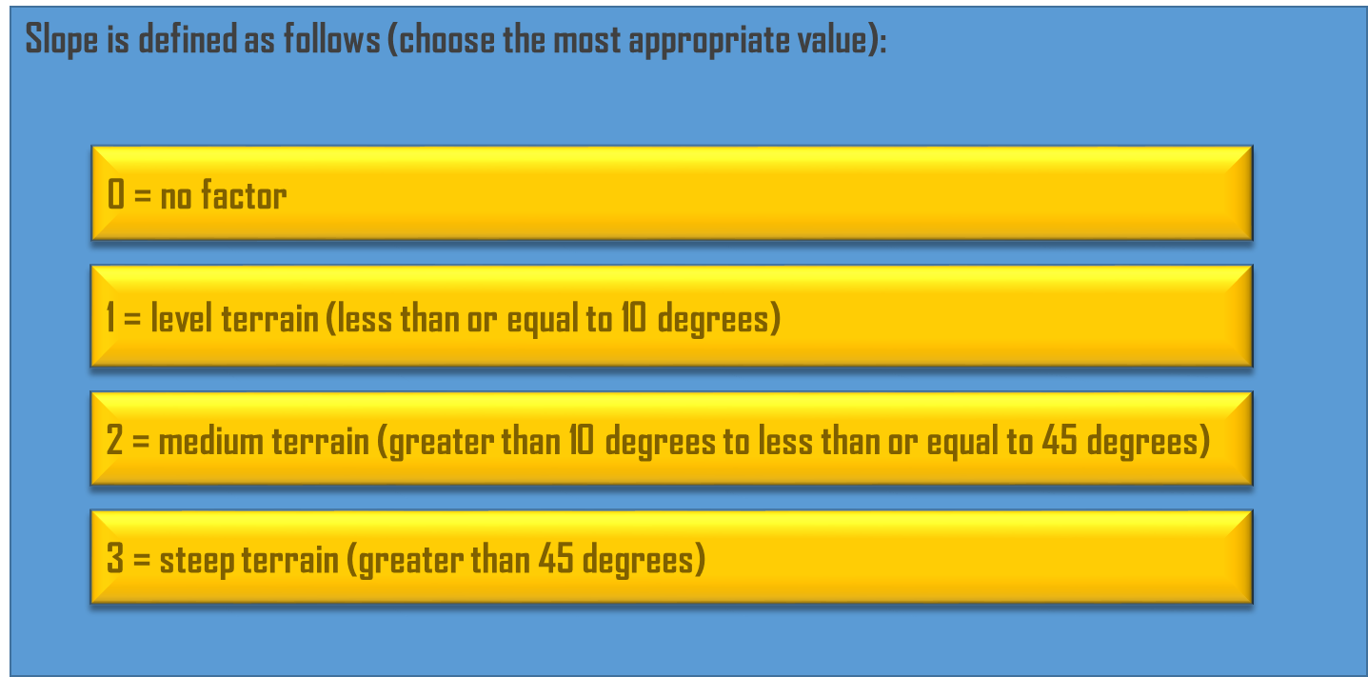

Figure 22: Define Slope of the Terrain

## Define Weighting Criteria

After defining the environment the user will now weight preferences among the performance characteristics of each technology set. There are 3 technology option buttons listed on the right side of the dashboard under the “Define Weighting Criteria” banner. Start by selecting the first option as shown in Figure 23.

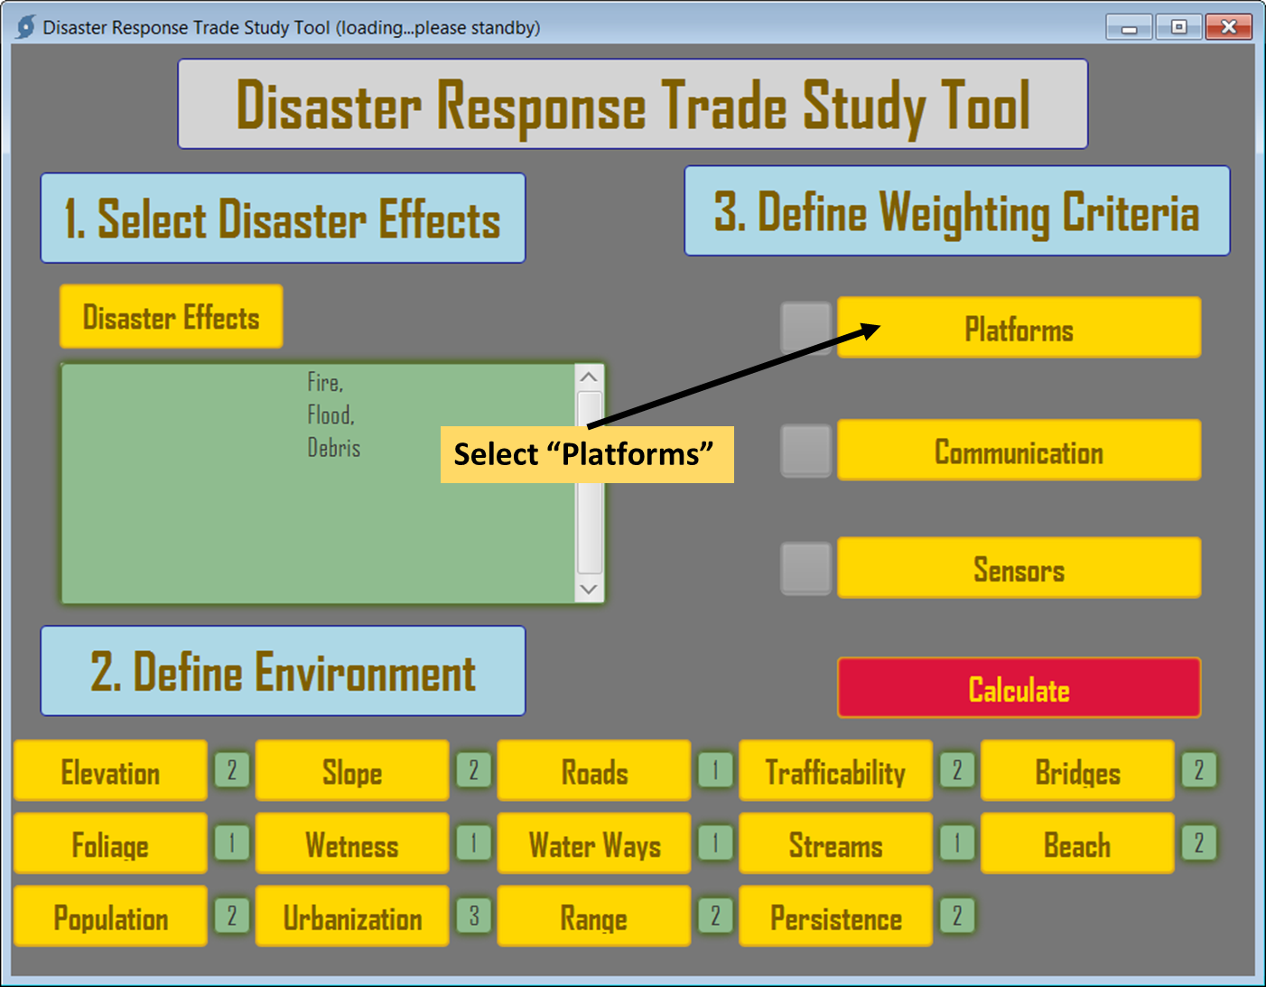

Figure 23: Selecting Weighting Criteria

When selecting the “Platform” button from the dashboard, the tool will take the user to a separate page which will ask a series of questions to determine relative weightings of various performance characteristics of air platforms (Figure 24).

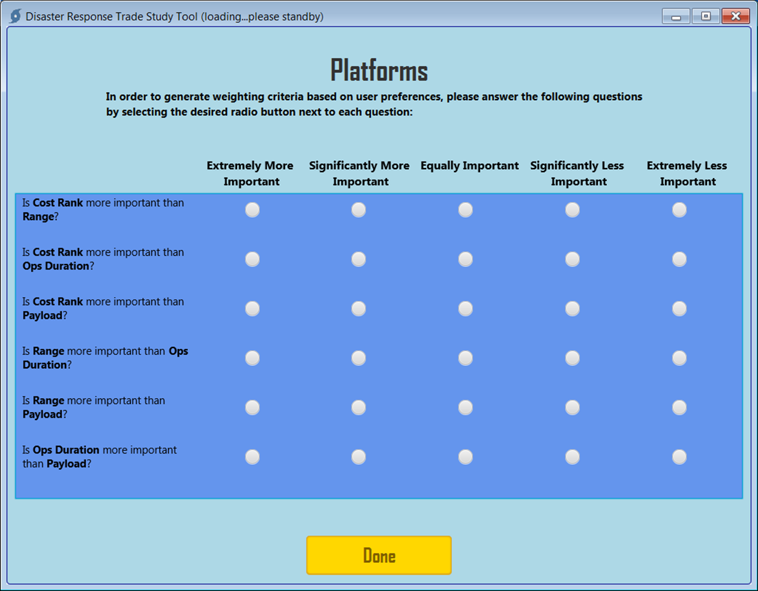

Figure 24: Platform Weighting Questions

For each question on the menu, click on the most appropriate response as it pertains to the using organization as it aligns to the chosen environment factors. Once all six questions on the menu have been answered, select “Done” and the tool will return to the dashboard. A checkmark will appear in the box next to the Platform button. The user should then continue by selecting the remaining weighting buttons, answering similar questions on each technology’s list of performance characteristics.

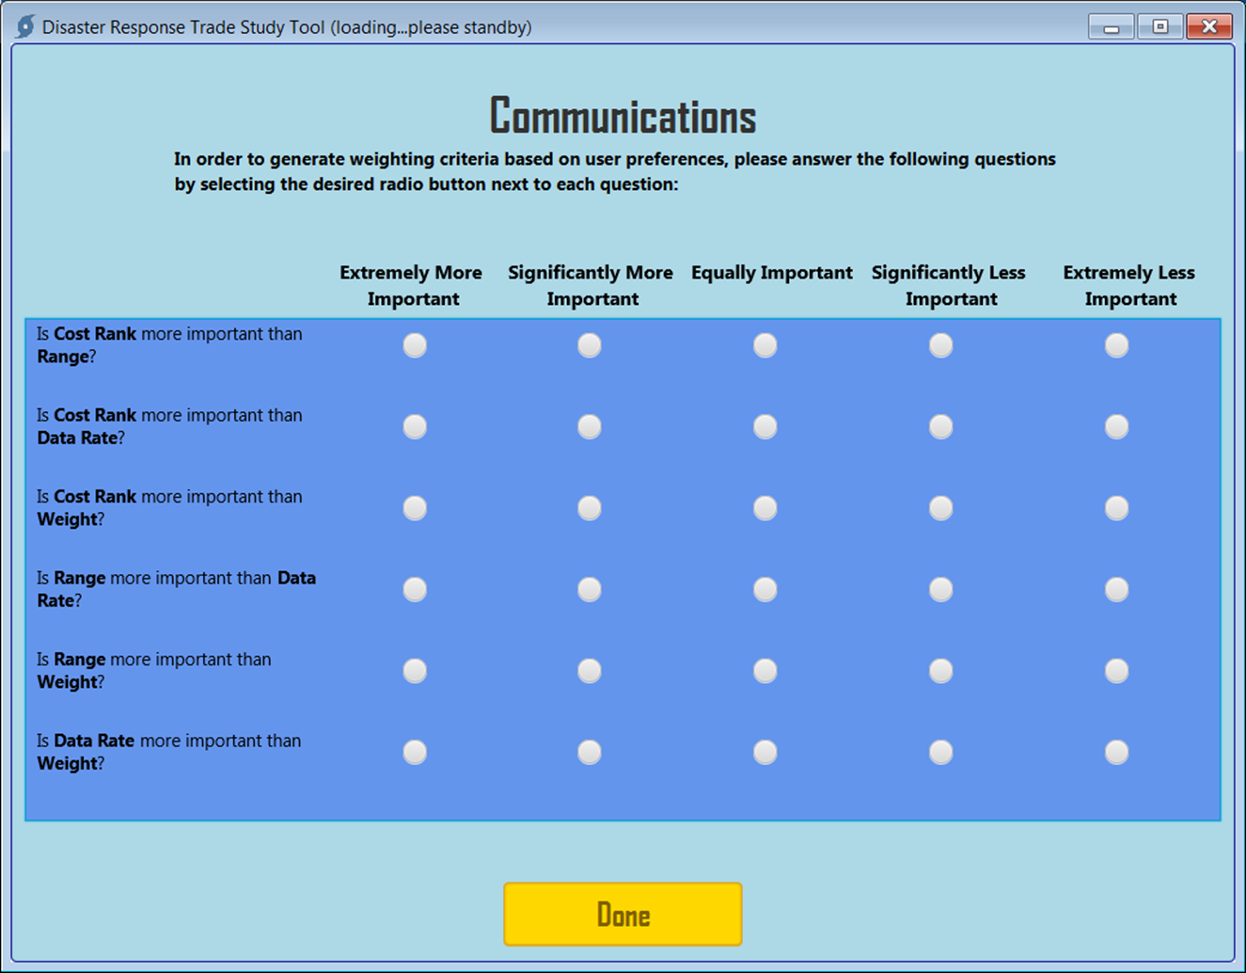

Figure 25: Communications Weighting Questions

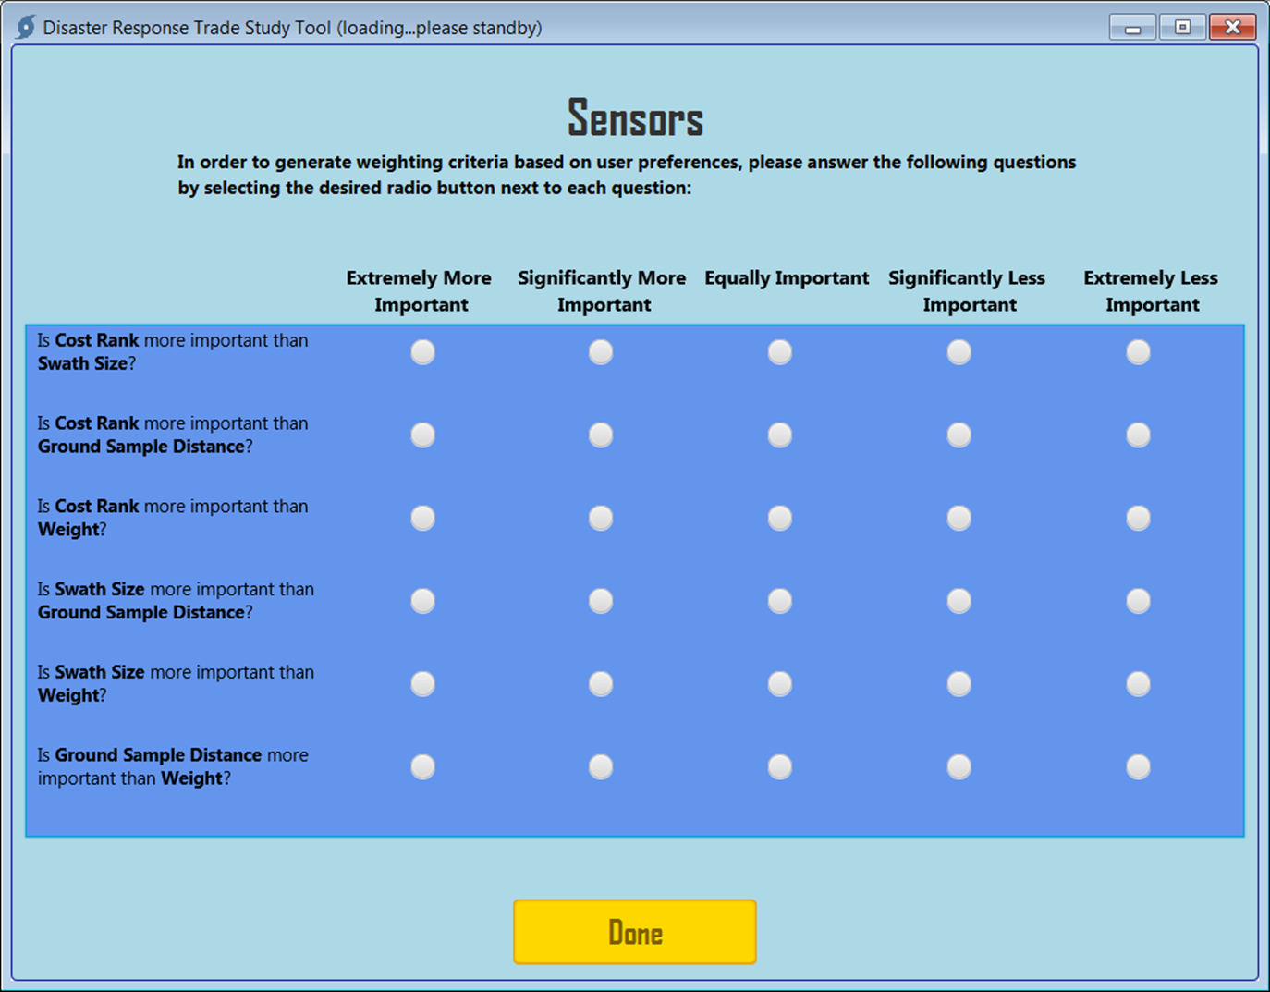

Figure 26: Sensor Weighting Questions

## Calculating the Results

Once all tasks in section 3 have been completed the “Calculate” button will turn green indicating that the technology trade study analysis can be executed. Select the “Calculate” button on the dashboard as show in Figure 27 to execute the analysis.

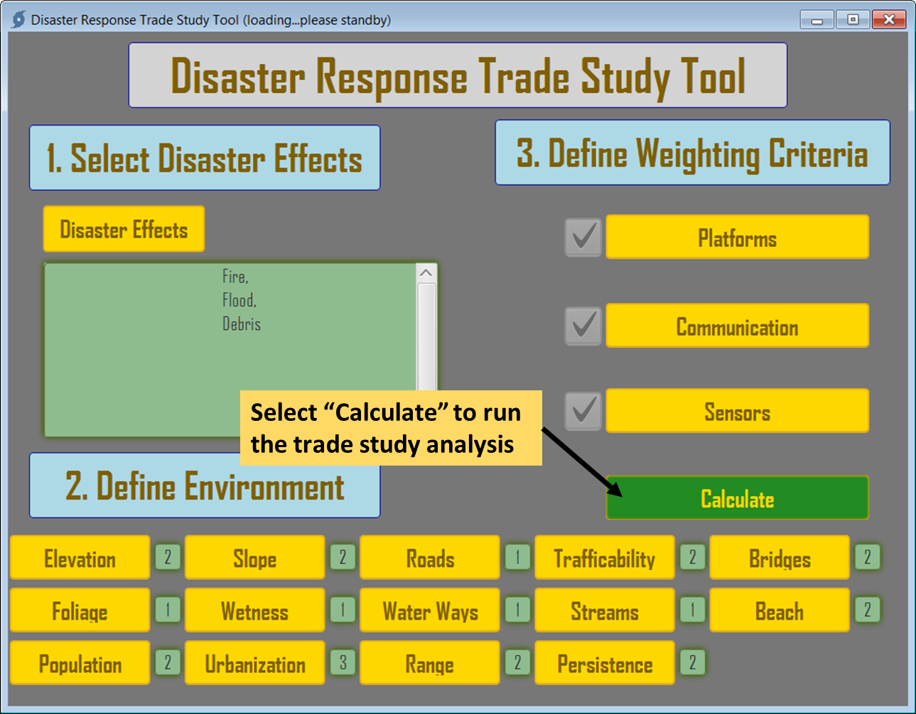

Figure 27: Executing Trade Study Analysis

Once the user selects “Calculate” a report of the recommended technology sets will be generated in Microsoft Word and will open automatically. This report can be saved or printed for reference. The report will show the highest weighted solution set based on user inputs. It will also show the user inputs and the resulting weighting calculations made by the tool’s trade study analysis. A sample of the report is shown in Figure 28 through Figure 31.

The report is automatically saved and stored in the “results” folder within the directory where the tool is maintained.

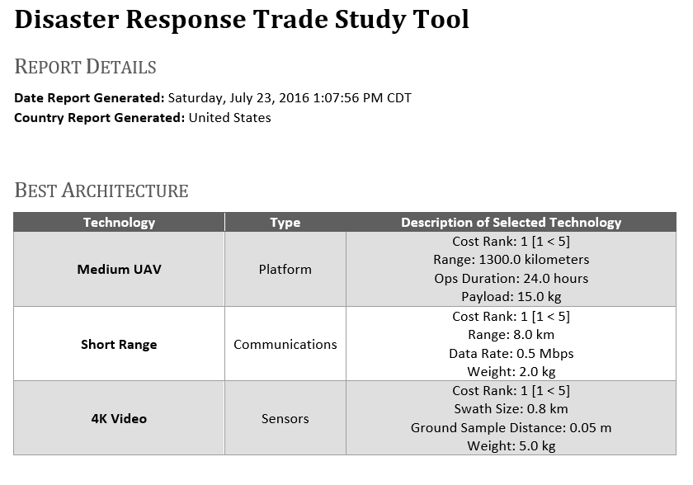

Figure 28: Page 1 of the DRTST Report

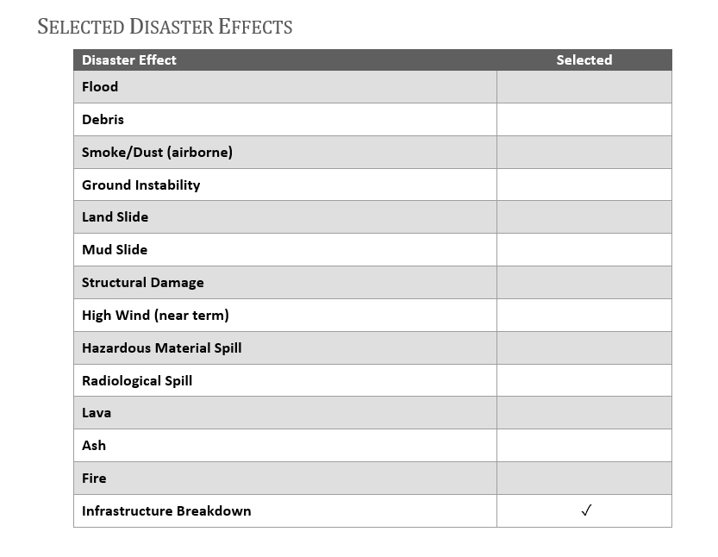

Figure 29: Page 2 of the DRTST Report

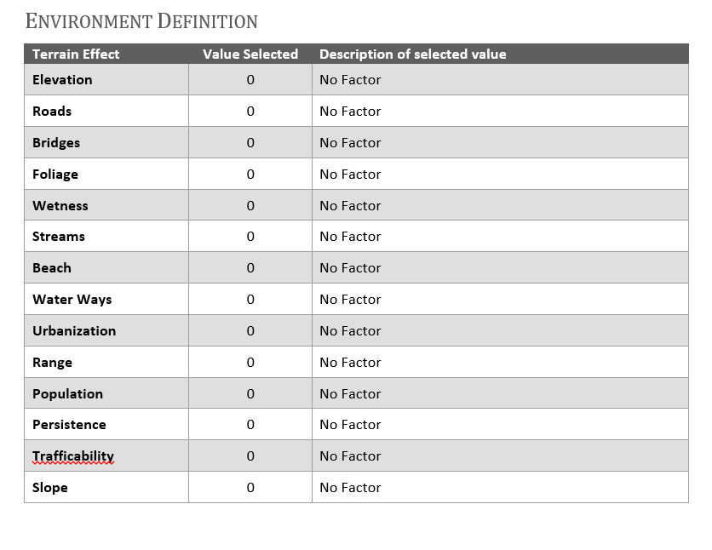

Figure 30: Page 3 of the DRTST Report

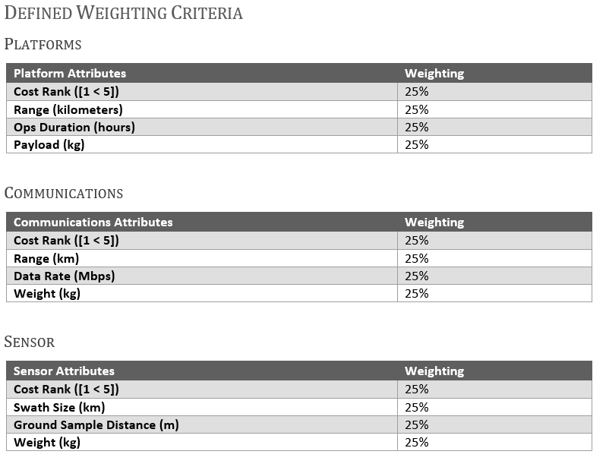

Figure 31: Page 4 of the DRTST Report

# DRTST Technology Databases

This section should only be used by subject matter experts to modify the DRTST technology databases. The DRTST program is setup to allow for expansions and modifications to the database to allow teams to increase the fidelity and applicability of the results to specific technology sets. This section of the user manual is intended provide users with the steps and constraints on updating these databases.

The Technology Database files contain the set of technologies from which the tool will select the optimum combination.

There are three input files required, each focusing on a technology piece of the recommended solution.

* PlatformDatabase.xlsx
* CommsDatabase.xlsx
* SensorDatabase.xlsx

## Platform Database

The platform database contains information on the platform types to be considered by the Disaster Response tool. Each row in the database can represent a class or a specific type of response platform.



Figure 32: Platform Database

1. **ID:** Sequential number identifying the platform’s position in the database.
2. **Name:** Text ID of the platform type or category.
3. **Cost Rank:** Normalized cost ranking scored from lowest cost (1) to highest cost (5) for the given platform.
4. **Payload:** Equipment carrying capacity of the given platform. This value excludes personnel or fuel weights.
5. **Type:** Identifies the platform as an air (A) or ground (G) asset.
6. **Terrain 1:** Numeric identifier of any terrain code 1 types that would significantly degrade the performance of the platform. If multiple codes are entered they shall be separated by a comma.
7. **Terrain 2:** Numeric identifier of any terrain code 2 types that would significantly degrade the performance of the platform. If multiple codes are entered they shall be separated by a comma.
8. **Terrain 3:** Numeric identifier of any terrain code 3 types that would significantly degrade the performance of the platform. If multiple codes are entered they shall be separated by a comma.
9. **Terrain 4:** Numeric identifier of any terrain code 4 types that would significantly degrade the performance of the platform. If multiple codes are entered they shall be separated by a comma.
10. **Disaster Effect:** Numeric identifier of any disaster effects that would significantly degrade the performance of the platform. If multiple codes are entered they shall be separated by a comma.
11. **Range:** Operational range of the platform in kilometers.
12. **Duration:** Operational duration of the platform in hours

## Communications Technology Database

The communications database contains information on the communication technology types to be considered by the Disaster Response tool.

Each row in the database can represent a class or a specific type of technology.



Figure 33: Communications Technology Database

1. **ID:** Sequential number identifying the technology’s position in the database.
2. **Name:** Text ID of the technology type or category.
3. **Cost Rank:** Normalized cost ranking scored from lowest cost (1) to highest cost (5) for the given technology.
4. **Weight:** Weight of the technology in kilograms.
5. **Platform Restrictions:** Numeric identifier of any platform types that would not be compatible with the technology. If multiple codes are entered they shall be separated by a comma.
6. **Terrain 1:** Numeric identifier of any terrain code 1 types that would significantly degrade the performance of the technology. If multiple codes are entered they shall be separated by a comma.
7. **Terrain 2:** Numeric identifier of any terrain code 2 types that would significantly degrade the performance of the technology. If multiple codes are entered they shall be separated by a comma.
8. **Terrain 3:** Numeric identifier of any terrain code 3 types that would significantly degrade the performance of the technology. If multiple codes are entered they shall be separated by a comma.
9. **Terrain 4:** Numeric identifier of any terrain code 4 types that would significantly degrade the performance of the technology. If multiple codes are entered they shall be separated by a comma.
10. **Disaster Effect:** Numeric identifier of any disaster effects that would significantly degrade the performance of the technology. If multiple codes are entered they shall be separated by a comma.
11. **Range:** Operational range of the technology in kilometers.
12. **Data Rate:** Data throughput of the technology in megabits per second.

## Sensor Technology Database

The sensor database contains information on the sensor technology types to be considered by the Disaster Response tool.



Figure 34: Platform Technology Database

1. **ID:** Sequential number identifying the technology’s position in the database.
2. **Name:** Text ID of the technology type or category.
3. **Cost Rank:** Normalized cost ranking scored from lowest cost (1) to highest cost (5) for the given technology.
4. **Weight:** Weight of the technology in kilograms.
5. **Platform Restrictions:** Numeric identifier of any platform types (reference section 4.1.A) that would not be compatible with the technology. If multiple codes are entered they shall be separated by a comma.
6. **Terrain 1:** Numeric identifier of any terrain code 1 types that would significantly degrade the performance of the technology. If multiple codes are entered they shall be separated by a comma.
7. **Terrain 2:** Numeric identifier of any terrain code 2 types that would significantly degrade the performance of the technology. If multiple codes are entered they shall be separated by a comma.
8. **Terrain 3:** Numeric identifier of any terrain code 3 types that would significantly degrade the performance of the technology. If multiple codes are entered they shall be separated by a comma.
9. **Terrain 4:** Numeric identifier of any terrain code 4 types that would significantly degrade the performance of the technology. If multiple codes are entered they shall be separated by a comma.
10. **Disaster Effect:** Numeric identifier of any disaster effects that would significantly degrade the performance of the technology. If multiple codes are entered they shall be separated by a comma.
11. **Swath Size:** Size of the ground swath that the sensor is capable of simultaneously imaging in kilometers.
12. **Ground Sample Distance:** The effective ground resolution of the sensor in meters.

## Terrain Effect Codes

The following codes will be used in fields F, G, H, and I for each of the databases.

Table 1: Terrian Effect Codes

|  |  |  |
| --- | --- | --- |
| Feature | Code | Meaning |
| Elevation | 0/1/2/3 | Low/Medium/High |
| Slope | 0/1/2/3 | Level/Medium/Steep |
| Roads | 0/1/2/3 | Paved/Unimproved/Few or None |
| Trafficability | 0/1/2/3 | Clear/Partially Obstructed/Obstructed |
| Bridges | 0/1/2/3 | Heavy Traffic/Medium Traffic/Foot |
| Foliage | 0/1/2/3/4 | Open/Partial/Complete/Triple Canopy |
| Wetness | 0/1/2/3 | Dry/Areas of Wetness/Marsh |
| Water Ways | 0/1/2 | Navigable/Unnavigable |
| Streams | 0/1/2 | Bridged/Unbridged |
| Beach | 0/1/2/3/4 | Gradual Sand or Pebble/steeper Sand or Pebble/Steep Sand or Pebble/Large Stone or Cliff |
| Population | 0/1/2/3 | Low/Medium/High |
| Urbanization | 0/1/2/3/4 | Open/Suburban/Urban/Dense Urban |
| Range | 0/1/2/3 | Near/Medium/Far |
| Persistence | 0/1/2/3 | Short/Medium/Long |

## Disaster Effect Codes

The following codes will be used in field J for each of the databases.

Table 2: Disaster Effect Codes

|  |  |
| --- | --- |
| ID | Disaster Effects |
| 0 | Unknown |
| 1 | Fire |
| 2 | Flood |
| 3 | Debris |
| 4 | Smoke/Dust/Ash (airborne) |
| 5 | Ground Instability |
| 6 | Land Slide |
| 7 | Mud Slide |
| 8 | Structural Damage |
| 9 | High Wind (near term) |
| 10 | Hazardous Material Spill |
| 11 | Radiological Spill |
| 12 | Lava |
| 13 | Ash |
| 14 | Infrastructure Breakdown |